
SRM Institute of Science and Technology
OFFLINE MODE
SET A
College of Engineering and Technology
DEPARTMENT OF ECE
SRM Nagar, Kattankulathur – 603203, Chengalpattu District, Tamil Nadu
Academic Year: 2021-2022 (EVEN)
Test: CLAT- 1 Date: 18-04-2022
Course Code & Title: 18ECC202J – Linear Integrated Circuits Duration: 60 minutes
Year & Sem: II / IV Max. Marks: 25
Course Articulation Matrix with PI:
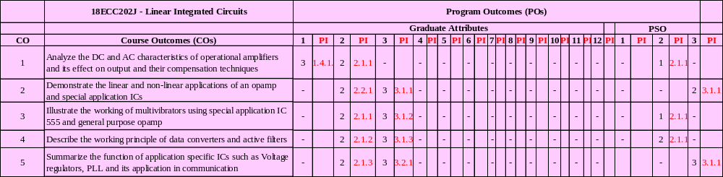

Part – A
(5 x 1 = 5 Marks)
Instructions: Answer all 5 questions
Q. No | Question | Marks | BL | CO | PO | PI Code
1 | An ideal op-amp is a  - Voltage-to-voltage amplifier  - Voltage-to-current amplifier  - Current-to-voltage amplifier  - Current-to-current amplifier | 1 | 1 | 1 | 1 | 1.4.1
2 | The op amp voltage follower is also known as  - Buffer  - Precision Diode  - Limiter  - Adder | 1 | 1 | 1 | 1 | 1.4.1
3 | Operational amplifier amplifies the following signals  - AC signals  - DC signals  - Both AC and DC signals  - Noise | 1 | 1 | 1 | 1 | 1.4.1
4 | What is the maximum output offset voltage for the non-inverting amplifier having input resistance (R₁) =6 KΩ and feedback resistance (R_{f} )=12 KΩ caused by input offset voltage V_{ios} =3mV ?  - 7mV C) 9mV  - 8mV D) 10mV | 1 | 3 | 1 | 2 | 2.1.1
5 | The output voltage of an op amp changes by 40V in 10µs. What is the slew rate of the op-amp?  - 4V/µs C) 8 V/µs  - 6V/µs D) 12V/µs | 1 | 3 | 1 | 2 | 2.1.1
Part – B
(10 x 2 = 20 Marks)
Instructions: Answer any 2
6.a | Explain the functions of various stages in an op-amp using its internal block diagram. | 6 | 2 | 1 | 1 | 1.4.1
6.b | Determine the difference voltage and an open loop op-amp gain in the circuit given below for the input voltages V₁= -4V and V₂=4V and output voltage V_{o}=20V.  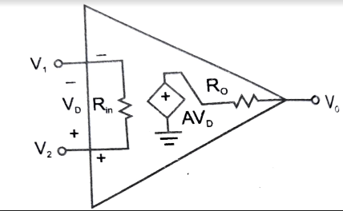 | 4 | 3 | 1 | 2 | 2.1.1
7.a | Define thermal drift. | 2 | 1 | 1 | 1 | 1.4.1
7.b | What is the need for frequency compensation? Obtain the compensated gain using dominant pole external frequency compensation technique. | 8 | 2 | 1 | 1 | 1.4.1
8.a | Explain in detail the inverting & non inverting amplifier and derive the expression for closed loop gain. | 6 | 2 | 1 | 1 | 1.4.1
8.b | A square wave of peak-to-peak amplitude of 500mV has to be amplified to a peak -to-peak amplitude of 3 volts, with a rise time of 4 µs or less. Can a 741 be used? | 4 | 4 | 1 | 2 | 2.1.1
Course Outcome (CO) and Bloom’s level (BL) Coverage in Questions

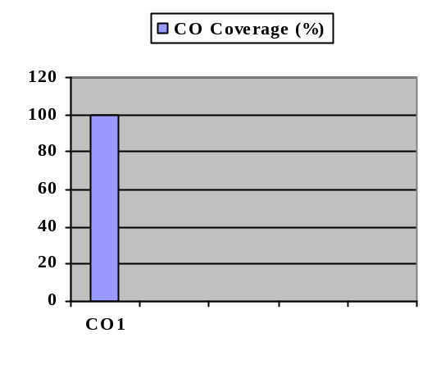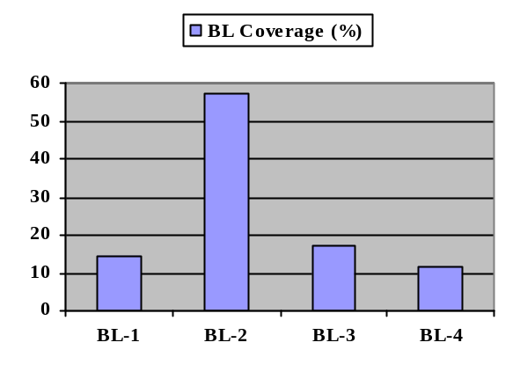
Evaluation Sheet
Name of the Student:
Register No.: RA2011004010

 |  | Part- A ALL FIVE (5x 1= 5 Marks)
Q. No | CO | Marks Allotted | Marks Obtained | Total
1 | 1 | 1
2 | 1 | 1
3 | 1 | 1
4 | 1 | 1
5 | 1 | 1
Part- B Any TWO (2 x 10= 20 Marks)
6.a | 1 | 6
6.b | 1 | 4
7.a | 1 | 2
7.b | 1 | 8
8.a | 1 | 6
8.b | 1 | 4
Consolidated Marks:
CO | Max. Marks Allotted | Marks Scored
CO1 | 25
Total | 25

Approved by the Course Coordinator

SRM Institute of Science and Technology
OFFLINE MODE
SET B
College of Engineering and Technology
DEPARTMENT OF ECE
SRM Nagar, Kattankulathur – 603203, Chengalpattu District, Tamil Nadu
Academic Year: 2021-2022 (EVEN)
Test: CLAT- 1 Date: 18-04-2022
Course Code & Title: 18ECC202J – Linear Integrated Circuits Duration: 60 minutes
Year & Sem: II / IV Max. Marks: 25

Course Articulation Matrix with PI:

Part – A
(5 x 1 = 5 Marks)
Instructions: Answer any 5
Q. No | Question | Marks | BL | CO | PO | PI Code
1 | Open loop gain of ideal op-amp is  - Unity C) Finite  - Infinite D) Zero | 1 | 1 | 1 | 1 | 1.4.1
2 | Output stage of an operational amplifier is designed to provide  - Low output impedance  - Moderate output impedance  - High output impedance  - Very high output impedance | 1 | 1 | 1 | 1 | 1.4.1
3. | The purpose of level shifter in op-amp internal circuit is to  - Adjust DC voltage  - Increase impedance  - Provide high gain  - Decrease input resistance | 1 | 1 | 1 | 1 | 1.4.1
4 | If the gain-bandwidth product of an op-amp is 2 MHz. What is its bandwidth when it acts as a voltage follower?  - 1MHz C) 3MHz  - 2MHz D) 4MHz | 1 | 3 | 1 | 2 | 2.1.1
5 | Calculate the maximum frequency of a sine wave whose output voltage is 15V peak in an op-amp of slew rate is 1 V/μs.  - 11.2 kHz C) 5.6 kHz  - 10.6 kHz D) 4 kHz | 1 | 3 | 1 | 2 | 2.1.1
Part – B
(10 x 2 = 20 Marks)
Instructions: Answer any 2
6.a | List the name of different IC packages. Draw the pin diagram and schematic symbol of an op-amp IC 741 and explain the function of each pin. | 6 | 1 | 1 | 1 | 1.4.1
6.b | Design an inverting and non-inverting amplifier with a gain of 12 and input resistance equal to 20kΩ. | 4 | 3 | 1 | 2 | 2.1.1
7.a. | Define CMRR. | 2 | 1 | 1 | 1 | 1.4.1
7.b | Obtain the compensated gain using pole-zero external frequency compensation technique. | 8 | 2 | 1 | 1 | 1.4.1
8.a | Obtain the compensation expression for the input bias current of an op-amp with relevant diagram. | 6 | 2 | 1 | 1 | 1.4.1
8.b | A non-inverting amplifier with a gain of 50 is nulled at 30ºC. What will happen to the output voltage if the temperature rises to 55 ºC for an offset voltage drift of 0.15mV/ºC? | 4 | 4 | 1 | 2 | 2.1.1

Course Outcome (CO) and Bloom’s level (BL) Coverage in Questions
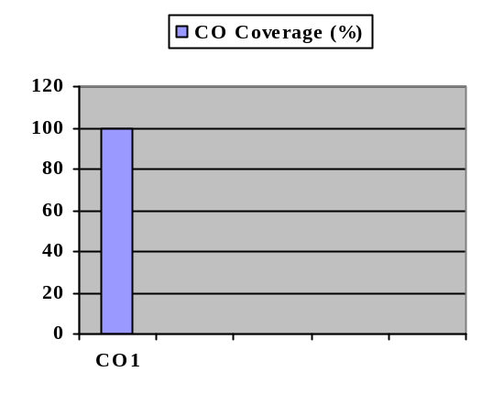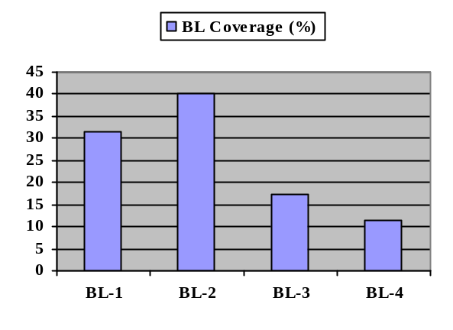

Evaluation Sheet

Name of the Student:
Register No.: RA2011004010

 |  | Part- A ALL FIVE (5x 1= 5 Marks)
Q. No | CO | Marks Allotted | Marks Obtained | Total
1 | 1 | 1
2 | 1 | 1
3 | 1 | 1
4 | 1 | 1
5 | 1 | 1
Part- B Any TWO (2 x 10= 20 Marks)
6.a | 1 | 6
6.b | 1 | 4
7.a | 1 | 2
7.b | 1 | 8
8.a | 1 | 6
8.b | 1 | 4

Consolidated Marks:

CO | Max. Marks Allotted | Marks Scored
CO1 | 25
Total | 25

Approved by the Course Coordinator

